

Analysis Of Tourism Sector in India

Using Python

I would like to thank all my supporters and well-wishers for believing in me. I extend my heartfelt appreciation to my colleagues and peers for their collaborative efforts and insightful discussions, which have enriched the project and contributed to its success. Their diverse perspectives and collective dedication have been a source of inspiration and motivation. Thanks to the people for entrusting me with this project, helping me to achieve the completion of the report.

Last but not least, I would like to thank my friends and family for the unwavering support, understanding, and encouragement throughout this endeavor. Their love, encouragement, and patience have been a constant source of strength and motivation, for which I am deeply grateful.

The dataset provided has total 8 files which are in CSV format and each file holds different kind of information. However, the dataset provided is from 2014 to 2020 which makes our research a little incomplete and old. Since this report is just a sample, we are going to include all the findings here.

As we know, Tourism in India has grown a lot since it’s independence and why will it not? You get different types of climates, seasons and ecosystems here. From mountains to deserts, plateaus to plains, etc. Each state has it’s own culture, language and traditions. Basically, visiting India means visiting different types of countries.

The report is going to discuss about the condition of tourism sector and how much it enhanced and contributed for our development. To represent each and every information, we have tried our best to plot as many graphs as we can in order to cover every hidden trend. We have used different kinds of graphs in order to get most of an information provided in the dataset. One by one, we will be looking at each topic and see what it tells.

The report is basically made to show about the condition of tourism sector in India and what improvements can be made from it. It might provide you some of the solutions for improving Indian tourism problems. Moreover, even though the dataset is old, still it can be used to find out the hidden trends which can be observed only in the older data. Let’s see what it holds and tells!

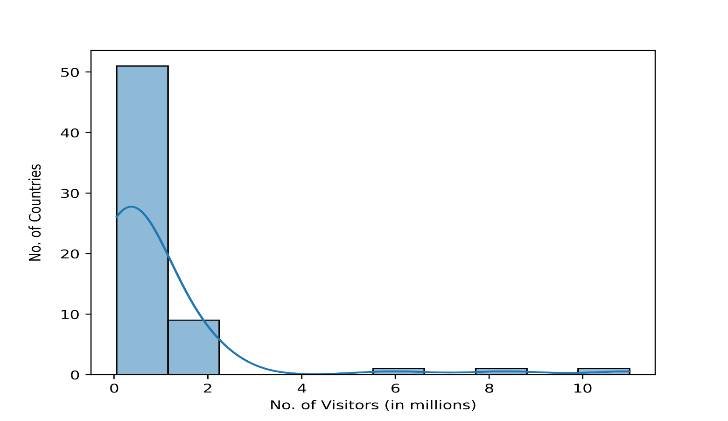

As we can see, the graph is telling about the frequency of population that visit India. Through the histogram graph, one can understand that only 0-2 million people come from around 50 different countries which is not that great as x-axis is the sum of 2014-2020 visitors. Only few countries are there from which we get more that 5 million tourists.

The wavy line represents the probability distribution of the frequencies and is called as KDE. One can conclude that receiving around 2 million tourists has the highest probability and it gets lower with increasing numbers.

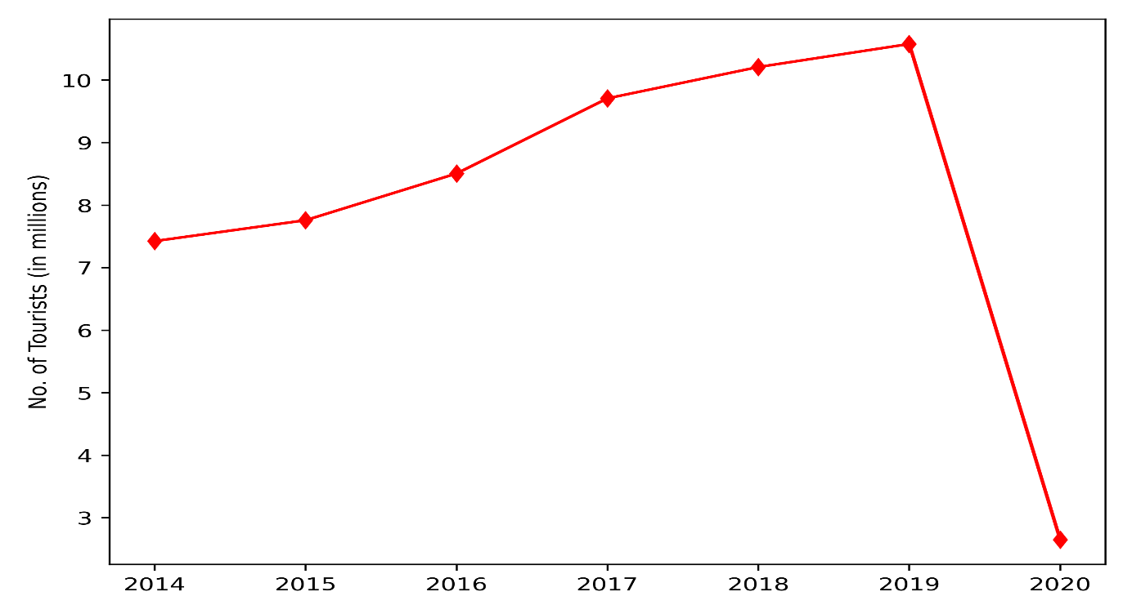

This is a line graph which represents the total number of tourists arrival in India each year. The line gradually increases from 2014 to 2019 and the peak of the tourism sector is on 2019. However, we know about the recent pandemic which led many countries in for a complete lockdown. Hence, the result of that lockdown can be seen after 2019, the line falls down so much that it is even below the initial point in 2014.

It’s really unpleasant because India’s tourism sector was quickly picking up the pace after the year 2016. If it wasn’t the pandemic then the sector would have bloomed really quickly by now.

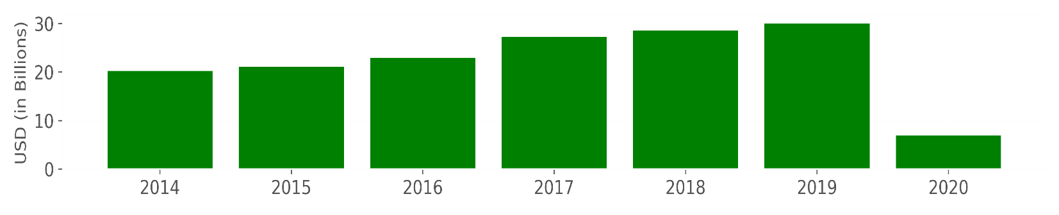

Above is a simple bar chart showing the amount of foreign exchange earnings each year. Foreign exchange earnings are basically based on the tourists, when they exchange the currency to rupees. Since, the y-axis is in billions, one can conclude that India earned a lot just by foreign exchanges. As usual, it can be found that the tourism sector bloomed way more in 2016 and it’s peak was at 2019, just like the previous graph. Things got messed up again in the year 2020 due to the pandemic which made India’s situation really worse as no other sector was earning that much than it used to.

By 2019, the tourism sector reached around 30 billion worth USD dollars and it could have earned even more after the year.

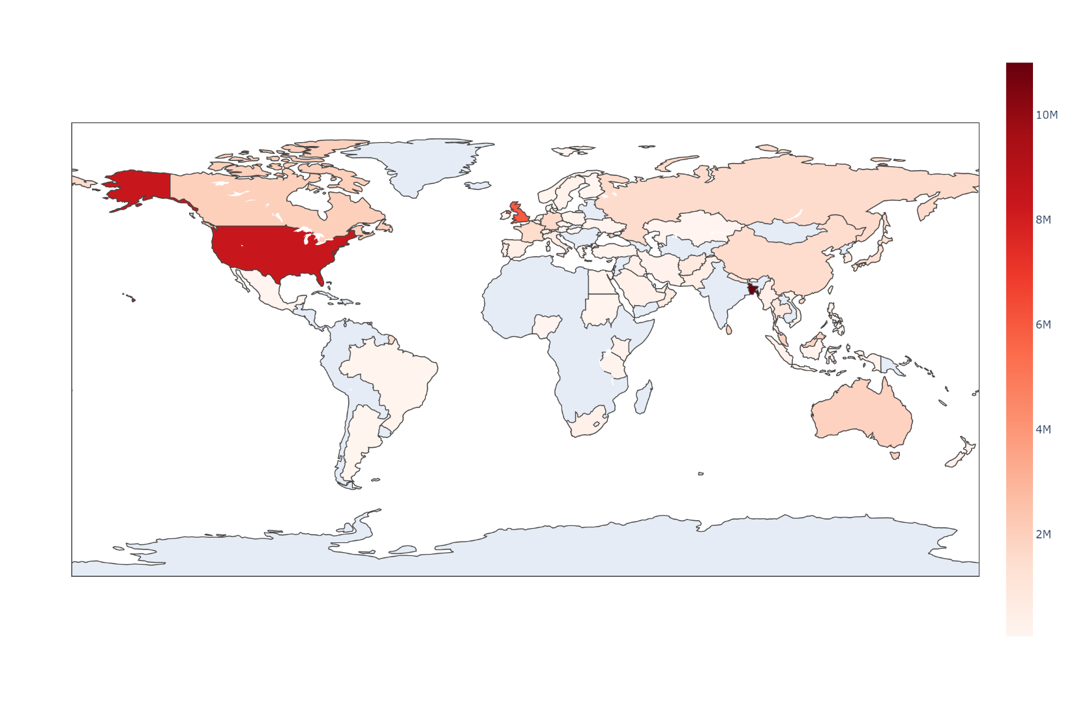This graph is a beautiful choropleth graph merged with a heatmap to represent the density of tourists who visit India. Having a closer look, one can easily observe that some of the countries are not colored and it means that they didn’t visit India even once. While, the western side of the earth is quite densely colored which says that North Americans love to visit India and prefer it as a better option for sightings, travelling, etc. While, moving to the Europe continent, not many countries would visit India. Even the same can be observed in Asia too.

It’s really hurtful that people from our own continent do not prefer to visit India much, while the Westerns choose India as a more preferred option for tourism.

In Asia, there is a little exception. With a closure look at south Asian countries, there’s a heavily colored country which is just beside India and that country is Bangladesh. It’s amazing to see that so many of the Bangladeshis prefer to visit India. The reason can be due to the good relations as well. It is always in the news that Bangladesh and India support each other and that’s maybe the reason of getting higher number of tourists from Bangladesh.

Countries on the Eastern southern side like South Korea, Indonesia, etc. would be less likely to visit India. This can have a lot of reasons which might get discussed in the report later on. For now, let’s have a look at the Top 5 countries which send highest number of people to India for tourism!

We have Bangladesh as the country from which we receive highest number of tourists! It could have been easily noticed as this country had the darkest color in the choropleth map.

Bangladesh has been in good relations with India for a long period of time and hence, it’s not a doubt that their people would love to visit India during their vacations. Let’s see some of the analysis on this country and find out if anything can be observed.

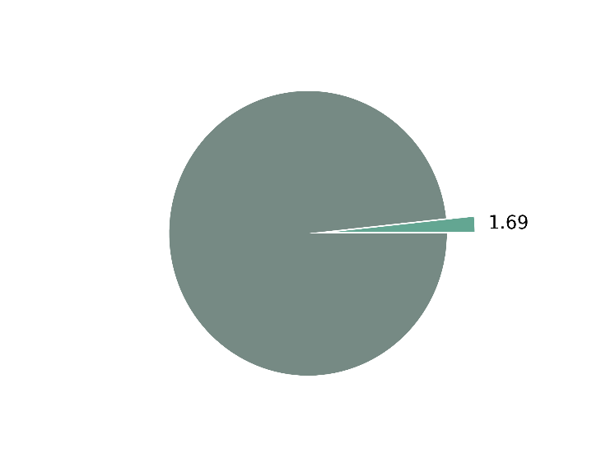As of 2019 data, around 1.69% of the total population has visited India. The population of Bangladesh was 16.5 crores during the year 2019. It shows that it is likely to receive a Bangladeshi tourist at popular tourist destinations. Of course, there can be a lot more reasons for the Bangladeshis to visit India but it’s a proud thing that India attracts around 1.7% of Bangladesh’s population which indirectly increases the GDP of India.

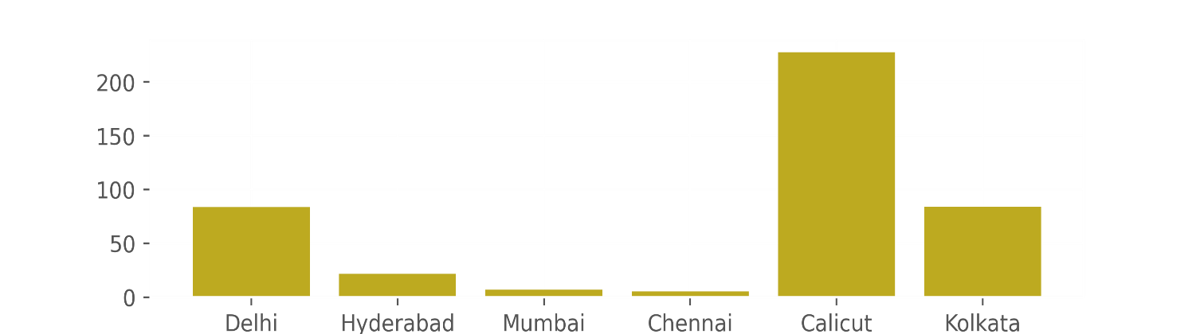

The above graph displays the bar graph of most preferred airports by Bangladeshis. A clear look tells that the Calicut Airport receives the higher number of travelers as compared to other states. Calicut Airport is situated in Kerala which seems quite odd as the distance between Kolkata and Bangladesh is really less which makes us think why there are less people in the Kolkata Airport. Even Chennai Airport also lies in the Southern India but still the travelers prefer to visit Kerala. Delhi Airport is understandable as it’s the capital of India. So, the question is what are the qualities Bangladeshis are getting from Kerala? Of course, there is no suspicion on their airport preference but in order to boost Indian economy, we should focus on raising the standards of each and every state in India so that tourists find comfort travelling to any of the places. Thus, that’s why knowing the airport preference can help to find a lot of hidden problems of various states.

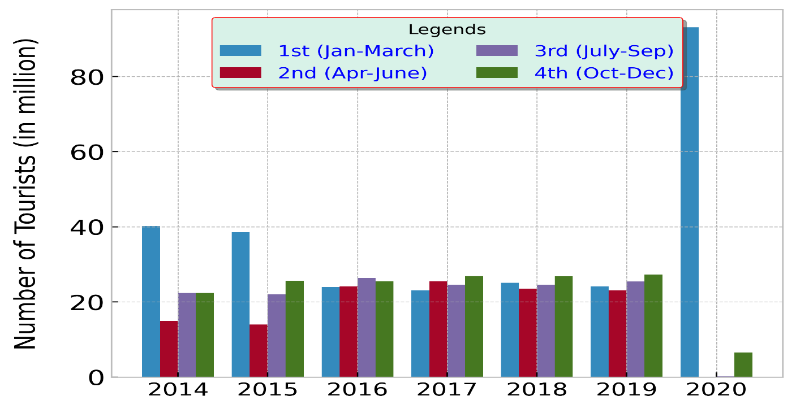

Next graph is regarding the number of Bangladeshi tourists visiting India categorized by the quarters of a year. A clear look tells that many tourists visited India in the early months of 2020 which might seem weird but it’s not. Simple idea is that, only 1st quarter of 2020 received around 90 million tourists while other quarters are close to null. But in other countries, the number seem very low but if you add up the quarters of every year, you will get a clearer picture that every other year is much more than 2020. So, what can we conclude from this? Most of the tourists from Bangladesh prefer to visit India during the first quarter (JAN – MARCH). However, if compared through years then the numbers have been reduced which appears that from 2017 onwards, people started to arrive during the last months of the year. Thus, this can help us to create a theory which says

that Bangladeshis visit India in the last months of a year, mainly to travel the southern side of India. Visualization is really helpful in exploring such topics deeply and develop newer rules and plans according to it. Let’s have a look at another graph which discusses about the age group of visitors.

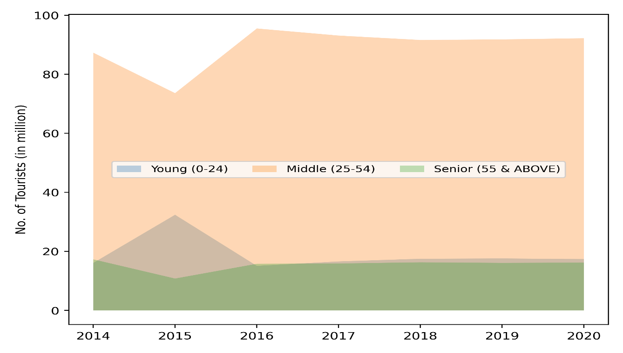

The graph came out as predicted. The number of seniors is less compared to Middle aged, while the young ones seem to be a bit odd as the peak was around 2015 and then suddenly went downhill but still it was above the number of seniors in next year. However, even if this pattern was already known, can we be sure that we will get to see the same pattern in other countries too? Let’s have a look at other countries now!

According to the dataset, the next country on the list is the USA! One of the most reputed countries of the world has been friendly to India since a long time and now we get to know that their contribution is not that less in tourism sector of India.

The USA stands 2nd in the position, just after Bangladesh for their tourism contribution. We have prepared graphs for all the countries in the list, just like shown in previous few sections. 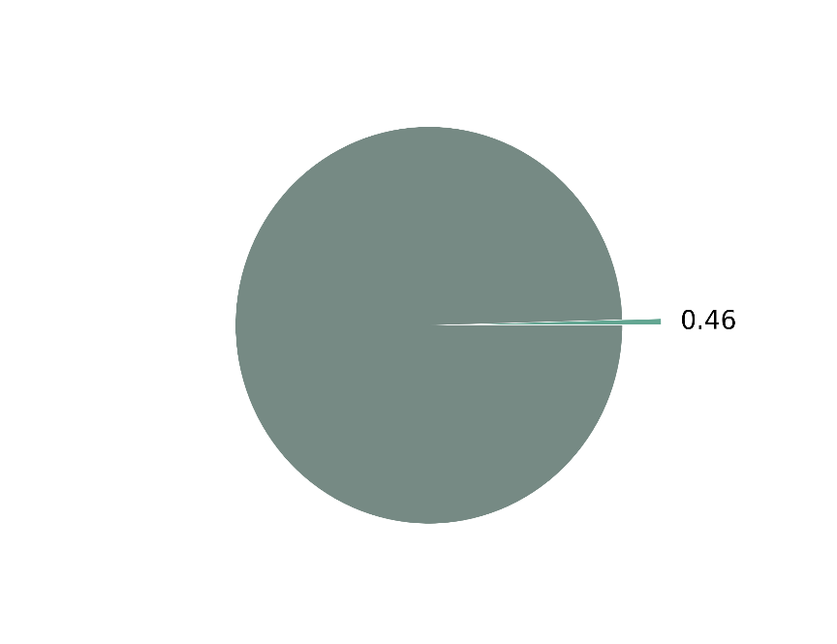

The pie chart displays that 0.46% of the total population of USA visited India during the peak time, that is 2019! It might seem to be a less percentage but mind that total population of USA during that time was 32,83,00,000 (approx.) and 0.46% of this population results in 15,10,180 which is not that less! Also, this number is just for a year, so you can guess for other years, this was the approximate number of tourist arrivals from USA. However, we cannot directly conclude anything without looking at the proofs, that is, graphs first. In the next page, we will start analyzing the graphs.

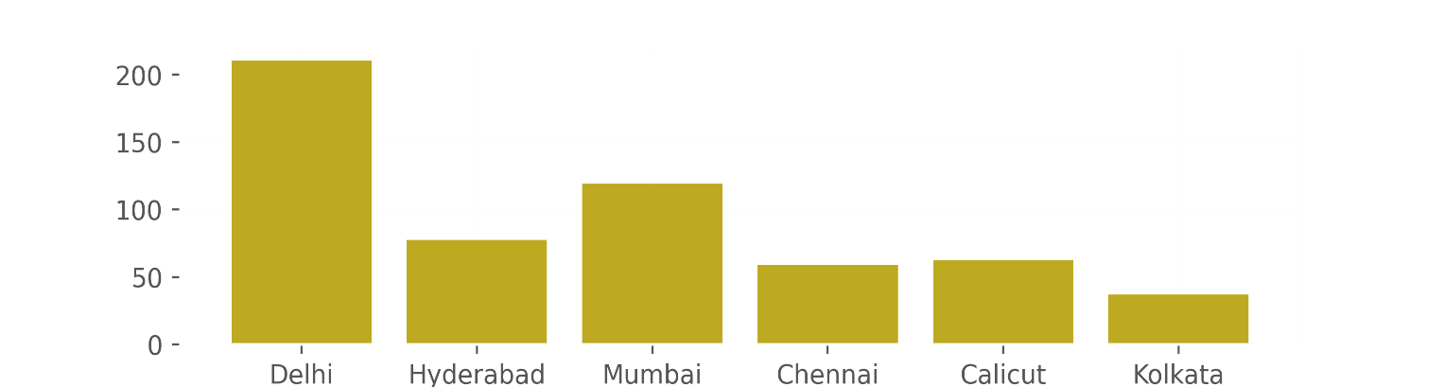

This is the usual expected airport preference chart of the tourists from USA. Delhi and Mumbai came to be on #1 and #2 respectively which can be well understood as these 2 airports are one of the famous airports known in the world for Indian Tour. According to this graph, we can kind of understand that USA citizens are more likely to visit the northern part of India for travel. Then some prefer to explore the Middle side of India and the lowest preference is to the Southern and Eastern of India. Most likely, we can conclude that they all come to visit the famous architectural structures which are mostly in Agra, Delhi, etc. Using the data, we can plan some of the strategies to boost economy! Let’s have a look at another graph which shows the number of tourist arrivals categorized by quarters of a ye

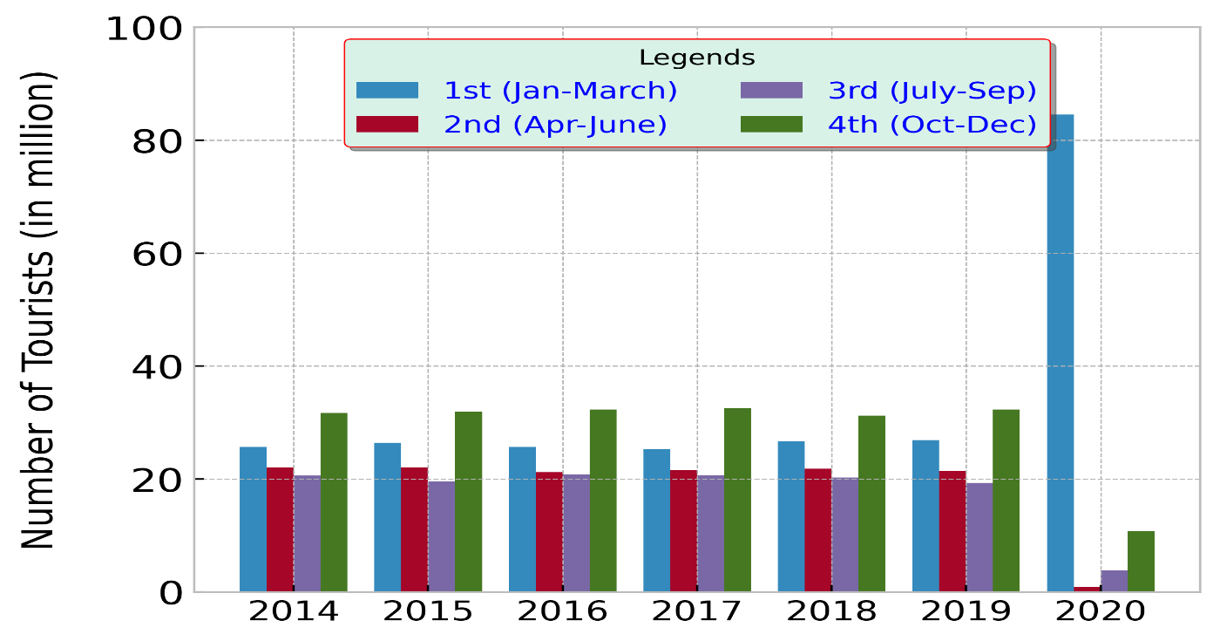

The same pattern can be seen in 2020 just like Bangladesh. However, from the year 2014, we get to know that we got tourists from USA in the last quarter of the year than other quarters. We can assume that these tourists prefer to visit India during the winters. We cannot jump to conclusions as there can be many reasons, one of that can be that they want to visit the hill stations in India and thus we find that they usually prefer Delhi Airport and mostly in the winter season. There are many of the hidden patterns which can be found on the basis of the data so we have to be always careful to not to jump on conclusions since wrong decisions can affect the whole tourism economy.

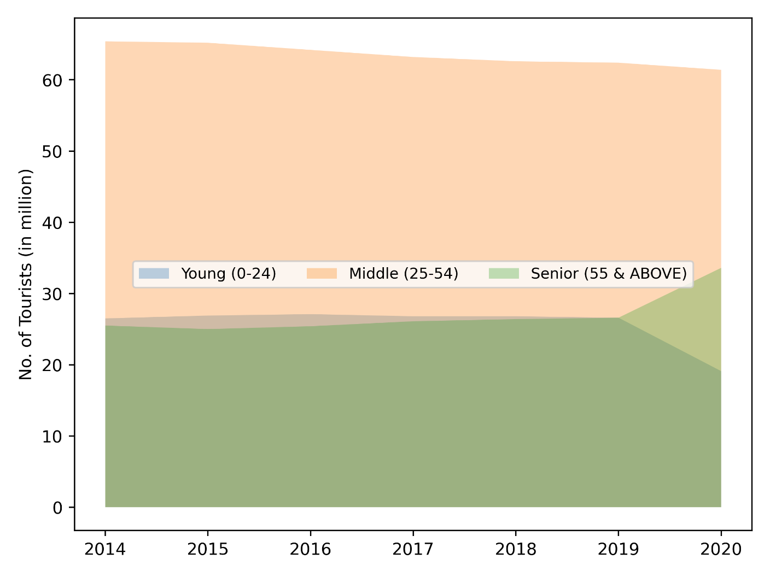

Here we can get to see the age group and hence, it can be concluded that middle aged people are more likely to visit India. However, in terms of young people, it is very less likely unlike Seniors. Is it because young people are not able to meet the required standards in our country? Or are they facing some kind of difficulty in order to visit India? It is import to know why as the young population are the new leaders of the new world and in order to build good relations with every country, it is important to make others see our capabilities in every area.

Now our next research topic is on United Kingdom one of the most controversial country in terms of Indian History and yet it is one of the major tourism boosting countries. The country which is known to have stolen a lot of wealth in the past is the third country in the leaderboard of countries. Let’s have a look at few of the graphs and figure out some of the common details which might help us to obtain some information.

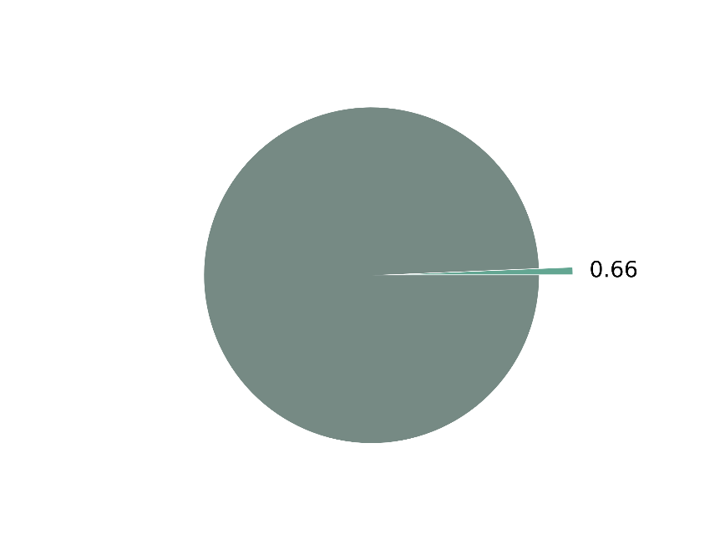Now as per pie chart, we have 0.66% of UK’s total population who are likely to visit India which is the least among all the countries till we have seen. However, still we can see that this country holds the 3rd position in the list. Is there anything else to notice? The total population of UK was 6.71 million, back in 2020 through which we can say that we got really low number of tourists from UK, so is there anything else which made them one of the major countries to visit India? Let’s find out!